**Intro to HTML**

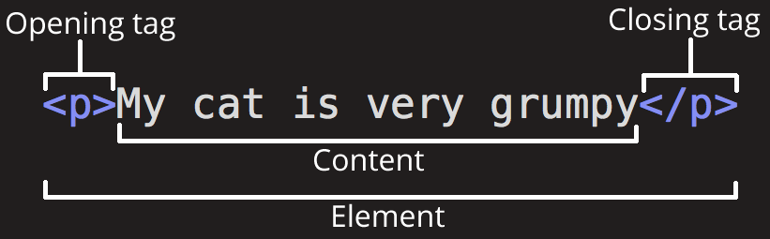

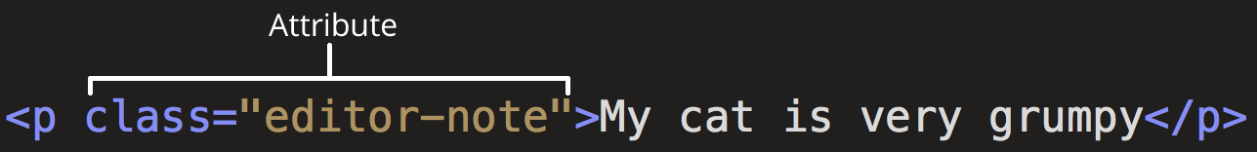

A basic document:

<!DOCTYPE html>

<html>

<head>

<meta charset="utf-8">

<title>My test page</title>

</head>

<body>

<h1>This is big header</h1>

<p>This is a normal paragraph</p>

<input type="text" disabled="disabled" title="input text here" />

<img src="picture.jpg" alt="My dog" width="240" height="360">

This text has a line break at the end and <em>emphasis</em>!<br />

<button>Click this</button>

This is a <a href="http://www.example.com">link to my example</a>.

</body>  
</html>

Definitions:

* The <html> tag is the root element of an HTML page
* The <head> tag contains meta information about the document
* The <title> tag specifies a title for the document
* The <body> tag contains the visible page content
* The <h1> tag makes nested text large heading style
* The <em> tag gives nested text emphasis (usually *italics*)
* The <b> tag makes nested text **bold**
* The <p> tag defines a paragraph
* The <button> tag defines a clickable button (use with <form> or JavaScript)
* The <input> tag defines a text input (use with <form> or JavaScript)
* The <a> tag defines a hyperlink to another location on the Internet
* The <img /> tag defines an image to display
* The <audio /> tag defines a sound file to play
* The <video /> tag defines a video to display
* The <br /> tag defines a line break

# **HTML Resources:**

**w3schools.com HTML5 Tutorial**

<https://www.w3schools.com/html/>

**Mozilla.org Introduction to HTML**

https://developer.mozilla.org/en-US/docs/Learn/HTML/

**Simple HTML Guide**

<http://www.simplehtmlguide.com>

# **JavaScript Resources:**

**w3schools.com JS Tutorial**

<https://www.w3schools.com/js/>

**Javascript Tutorial**

<https://javascript.info>

(Or peek behind the snap-together elements on Code.org)

**Intro to JavaScript**

<p id="demo">This is a normal paragraph</p>

<div id="divColorChanger">This text might change color.</div>

<input type="text" id="favoriteColor" title="Hi!"></input>

<button id ="btnSpecial" onclick="changeTheColor();">Click this</button>

<script language="JavaScript">

var firstName = "Chuck";  
var lastName = "Demoguy";

alert(firstName + " " + lastName);

var theProduct = myMultipler(6, 7);

document.getElementById("demo").innerHTML = "Hello JavaScript! <br />"

+ "The current date/time is: " + Date() + "<br />"  
+ "6 times 7 is: " + theProduct + "<br />";

function myMultipler(p1, p2) {  
 return p1 * p2; //Function returns the product of p1 and p2  
}

function changeTheColor() {

var c = document.getElementById("favoriteColor").value;

//alert(c);

document.getElementById("divColorChanger").style = "color: " + c;

}

</script>